Artemis & Angel Co. Ltd.
99/296 President Park, Sukhumvit 24, Klongtoey,
Bangkok 10110, Thailand
Tel.: (President) +66-86-329-6038; (Sales): +66-99-337-7866
E-mail: (Sales) artemisandangelcoltd@gmail.com Website: www.artemisthai.com
How to Make Rich Compost Using the 100% Organic, Liquid Bio-fertilisers,
Bio-Plant and Pro-Plant. A Summary of the Workshop Handouts.

Introduction
- The solution to soil infertility and disease problems is to restore the soil biology, which chemicals and bare soil have damaged severely over the years. Bio-Plant is very concentrated and contains a wide range of bacteria and fungi, which multiply rapidly to restore the soil biology. Compost made with Bio-Plant makes the bacteria and fungi grow rapidly; gets the heat up to kill soil pathogens; and creates very rich compost, which restores the soil biology, Soil Food Web, and Nutrient Cycle.

1.1 How to Make a Layered Compost Pile (This is explained in detail in the workshop handouts.)
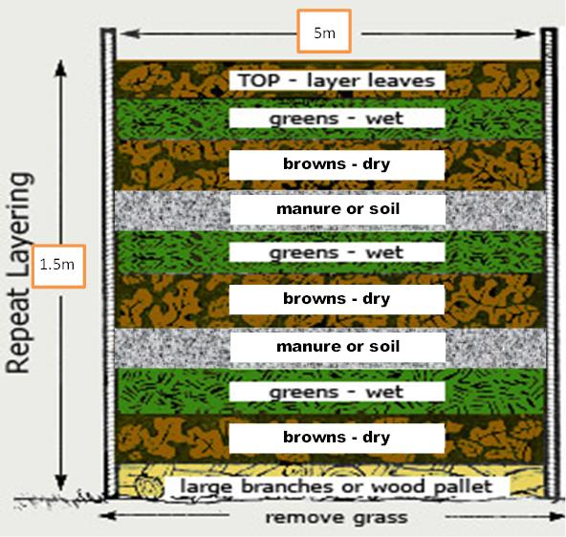
1.2 How to Start to Make the Compost Heap
- Set up the site in the shade of trees. Mark out the area for the compost heap. An area to make a minimum amount of compost for a hectare (5 MT) is 1 m x 5 m x 1.5 m. Dig a shallow trench. The foundation layer of compost-making materials is placed in the trench or pit. (See below.)

1.3 The Layers in Making the Compost Heap
1.3.1 The Foundation Layer

- Dry plant materials, e.g. twigs, thick straw, and stalks of maize and/or sorghum are used for the foundation. Spread the dry materials evenly over the bottom of the trench to make a layer about 25 cms. thick. Then sprinkle water mixed with Bio-Plant at the ratio of 20 cc in 20 litres of water with a watering can so that the material is moist, but not soaking wet. The foundation layer provides ventilation for air to circulate, and for excess water to drain out.

1.3.2 Layer 1 (Carbon - Brown Material) – Fungal Food
- Place a 25 cms. thick layer of cut up or ground brown, dry plant materials, such as dry leaves, crushed sugarcane waste, cocoa pods, straw, dried grass, dried weeds, stalky crop residues such as rice and maize stems, bran and rice husks, pruned material, and dry hay. It is important to make compost, which is rich in fungi, because then the weeds will grow less and less.

1.3.3 Layer 2 (Nitrogen - Green Material) – Bacteria Food
- Add a 25 cms. layer of moist (but not wet), green, plant materials, either fresh or wilted, e.g. weeds or grass, green stems and leaves from harvested vegetables, damaged fruits and vegetables, leafy branches from woody plants, banana leaves, etc. Greens are food for bacteria. Cut up the material into small pieces or grind it up.

1.3.3 Layer 3 (Manure) – High Nitrogen
- Add a layer of animal manure collected from dried and crushed cow dung, horse, mule or donkey manure, sheep, goat or chicken droppings.

- Note: Sprinkle water mixed with Bio-Plant on each layer at the ratio of 20 cc in 20 litres of water. This will make the bacteria and fungi grow rapidly.

1.3.4 Suggestions for Improving the Compost Pile (Included in the workshop handouts.)

1.3.5 The Carbon to Nitrogen Ratio
- To keep it simple, aim for a ratio of 2 to 2.5 parts of Browns to 1 part of Greens. 2 shovels of Browns, 1 shovel of Greens and ½ shovel of High Nitrogen.

1.3.6 Making the Covering Layer
- The finished heap needs to be protected from drying out. The covering layer can be made of thick straw or wet mud mixed with grass or straw, with or without cow dung; or wide leaves of pumpkin, banana trees, etc.; or plastic; or any combination of these materials.

2. What to Do During the Compost-Making Process
2.1 Using a Temperature Stick or Rod
- Place a temperature testing stick vertically and every 1 metre in the compost heap, remembering to have the stick long enough to stick out of the top of the heap. To measure the temperature, if you do not have a thermometer, remove the stick and place it on the back of your hand. If it is warm, the pile is not hot enough. If it feels very hot, but is bearable to touch, the temperature is probably at the maximum. If it is too hot to touch, it is time to turn over the pile immediately. An overly hot heap loses excessive amounts of nutrients and micro-organisms.

2.2 Using Your Arm to Assess the Temperature
- If you can hold your arm in the pile up to your elbow for longer than a few seconds, the heap is not 55º Celcius and is not hot enough. If you can hold your arm in the pile up to your elbow for just a few seconds, the heap is probably hot enough. If, however, you cannot even hold your arm in at all, then the heap is over 65º Celcius and too hot.

2.3 Checking the Temperature
- A pile should be aerated by turning it at least 5 times during the 15 days. After 15 days the pile will heat up to close to the 55º Celcius level before cooling again. When you notice it is cooling, turn the pile again. Keep doing this until the temperature no longer increases and the compost has a beautiful earthy smell and a fine texture with little or no evidence of the original ingredients.
- After one month, you should have turned the pile about 7 times, probably every 2-5 days after the first 15 days. By then you will not be able to tell the Greens from the Browns as the organic matter will have broken down. The stick or rod will gradually feel warm rather than hot, and as
the heap cools it will sink more and more.

2.4 Correcting the Problems (This is included in the workshop handouts.)
- If the materials are cool and dry.
- If the materials are too wet.
- If the compost heap smells.

2.5 Checking the Moisture Level
- The moisture level is critical and should remain between 45%-55% during the heat cycle. This is measured by taking a handful of compost from near the centre of the pile and squeezing it hard.
- If water runs out – compost is too wet and well in excess of 55% moisture.
- If one drop comes out – compost moisture is excellent at around 50-55%.
- If no drop comes out but the compost stays in a tight lump, the moisture is between 45-50%.
- If no water comes out and the squeezed compost breaks apart - moisture is less than 40% - add moisture when you turn it.

3. Turning the Compost Pile
3.1 How to Turn the Pile
- Use a pitch fork to build a fresh heap next to the original pile. Take the top off and put it on one side. Take the hot centre and place it on the ground around the edges of the new compost pile. Place the outside of the old pile and put it in the new centre. Place the old top of the pile in the new centre as well.
- Every time you turn the compost, make sure you bring the pile's exterior material into the interior. This enables all material to be evenly broken down. Water can be added to maintain the correct moisture levels, but be careful as the pile will cool if it is too moist.

3.2 Why You Should Turn the Pile (This is included in more detail in the workshop handouts.)
- Turning allows you to re-introduce oxygen that is rapidly being used by the aerobic microbes. It is also likely that additional moisture will be required on each new layer as it is created.

4. When is the Compost Finished?
- Compost is ready when it looks, feels, and smells like rich, dark earth rather than rotting vegetables. In other words, it should be dark brown, crumbly and smell like earth. The compost might not heat up when it is turned, but this does not mean that it is ready to be used. Compost is not finished until it has been cured. Curing takes 1-2 months once the pile is cool.

4.1 The Importance of Curing Compost
- When the pile no longer heats up, mesophyllic micro-organisms move in to finish the compost. The extra time for curing allows the microbes that operate at lower-temperature to put their finishing touches on the pile. It also allows earthworms and other larger organisms which do not tolerate high heat to move back into the compost. They improve the compost itself and then they improve the soil where the compost is added.
- Keep the pile damp by spraying water on it. These micro-organisms need moisture.
- Curing assures that the compost will be of a much higher quality. For example:
- The pH will become neutral.
- Uncured compost may contain substances damaging to plants, including acids and pathogens. Soil micro-organisms will colonise the compost and impart disease-suppressing qualities to it.
- If there is too much Carbon in the compost because you got the ratio of carbon to Nitrogen wrong, this will cause a temporary Nitrogen deficiency in the soil. Why? Because the micro-organisms will take Nitrogen from the soil to break down the rest of the Carbon. But the micro-organisms will restore the balance of Carbon and Nitrogen to the compost during the curing process. Having said this, if there was too much Carbon, the pile you would know because it would not become very hot and it would take a long time for the compost to develop. So you would have added green material.
- Curing makes the compost optimum for plant growth.
- For all of these reasons, it is important that compost is thoroughly mature before it is used.

4.2 How to Know When the Compost is Ready
- If you have a hot pile that has been turned regularly, knowing when it is done is easy: it will not heat up any more, even after being turned.
- After curing for 1-2 months.
- Check for fine particle, dark-coloured humus-like appearance and an earthy smell.
- In completely finished compost made from shredded materials, none of the original ingredients will be recognizable. If you do not shred ingredients, however, the decomposition will take a long time.
- The important test for whether cool compost is done is the look, feel, and smell of it. Mature compost does not contain slimy things, for instance. The ingredients should be unrecognizable, save for the occasional woody stem or autumn leaf. If many ingredients can still be picked out and named, the compost needs more time.

4.3. Screen the Compost Before Using or Bagging
- Screening compost takes time, but it results in a gorgeous, light and uniform soil.

5. Final Comments
- The cured compost will make excellent, rich fine potting soil.
- When this compost is placed in the planting rows and holes, and additional compost is added during the crop, the soil biology will be restored; the Nutrient Cycle will function as it should in the Soil Food Web once again; the plants will get the 42+ nutrients they need in the right quantities and at the right time; the disease-causing nematodes and fungi will not be able to dominate the soil; the plants will grow free of disease; weeds will not be a problem as the bacteria and fungi increase in the soil; and the crop yields will increase each season. All of this can be done for a much lower cost than in chemical agriculture. Indeed, chemical farming can be replaced throughout the country with 100% organic farming with all the economic, social, health, and environmental benefits, which this entails.

