Artemis & Angel Co. Ltd.
99/296 President Park, Sukhumvit 24, Klongtoey,
Bangkok 10110, Thailand
Tel.: (President) +66-86-329-6038; (Sales): +66-993377866
E-mail: artemisandangelcoltd@gmail.com Website: www.artemisthai.com
How to Grow Rubber Trees with Bio-Plant and Pro-Plant

1. Compost and Soil Preparation

- See the file at Section 3.2 called How to Make Rich Compost with Bio-Plant – Handouts. Click here for how to make rich compost with Bio-Plant. Scroll down to Section 3.2. Soil preparation with a lot of compost made with Bio-Plant will be invaluable in increasing growth. Add compost to the planting holes and spread it generously around each tree after planting. Add more compost around each tree monthly.
- If you do not make compost, refer to the file at Section 3.7 called: How to Prepare the Soil with and Without Compost. Scroll down to Section 3.7. Click here.

1.1 Soil Improvement
- If the trees are small, spray the soil at a suitable distance from the tree where the roots are and the leaves have fallen (up to the Drip Line usually) once every 2-4 weeks (every 2 weeks is better) with a mixture of 100 cc of Bio-Plant in 100 litres of water. Pour about 2-3 litres of the mixture at the base of each tree.

Rubber Tree Age in Months | Fertilizing Area (Away from the trunk)
2 Months | Starting 30 cms. from the tree trunk.
4 Months | Starting 35 cms. from the tree trunk.
6 Months | Starting 35 cms. from the tree trunk.
11 Months | Starting 50 cms. from the tree trunk.
14 Months | Starting 60 cms. from the tree trunk.
18 Months | Starting 1 metre from the tree trunk.
54 Months | Fertilize Around the Tree at a Radius of 2.5 metres.
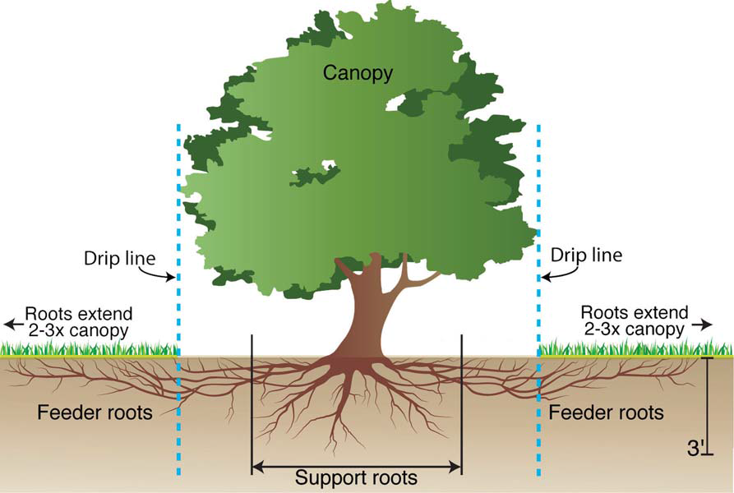

Diagram showing the Drip Line for placing compost for the support roots
and feeder roots.

- The Bio-Plant provides extra nutrients by dissolving the leaves. The Bio-Plant is applied to the base of the trees in the same row. It is beneficial to add more micro-organisms often as this enriches the soil and increases the growth of the trees and yield of latex. Leaves fall during the growth of the trees, and if you add Bio-Plant, ideally by spraying, as this spreads out the micro-organisms better, the micro-organisms will dissolve the nutrients in the leaves and add these to the soil by the roots.
- We recommend this because often chemical fertilizers have been used for so long that the micro-organisms in the soil have mostly been killed off, and there is a lack of minor minerals. The farmer needs to try to restore the soil as quickly as possible so that it does not need a “fix” of chemical fertilizer in order to produce growth in the trees.
- We also recommend mixing the 2-3 litres of water mixed with Bio-Plant with organic matter and placing this in a ring around the base of the tree at a distance suitable for the tree’s age. This is better than just pouring the 2-3 litres around the base of the tree without organic matter. The fallen leaves could be raked into a ring around the tree at the suitable distance and the Bio-Plant could be sprayed on the ring of leaves. The Bio-Plant’s micro-organisms will then have organic matter to multiply in. The farmer could do this once a month and spray once a month or apply bio-compost once every two months.
- Bio-Plant Used: In Compost - If there are 350 trees per hectare, one litre in 5 MT of compost would certainly cover 2 hectares. If you apply this every 2 months, you will use 3 litres per hectare per year.
- If you prefer to spray Bio-Plant every month, and spray 2-3 litres of water mixed with Bio-Plant per tree, you will need 0.75 - 1 litre per hectare per month. The farmer can decide the amount and the frequency. You could apply Bio-Plant in this way every 2 months if you wish to lower your costs. The greater the frequency you apply Bio-Plant, the better it is for the health of the soil and the trees, and the yield. When the latex is flowing, it is better to apply Bio-Plant mixed in water once a month rather than every 2 months.
2. Spraying the Leaves With Pro-Plant

2.1 If the tree is not too tall to spray (including seedlings in a nursery), mix Pro-Plant (100 cc) in water (100 litres). Spray Pro-Plant on the leaves every 14 days. 10 days is better as the tree will obtain more nutrients. This increases the yield.
- Spray the leaves of the trees. Spray before 9 a.m. when the pores are open most for better results. Please spray Pro-Plant using spraying equipment that gives a fine, misty spray, and that the spray is directed diagonally upwards so that it hits the pores of the leaves underneath as well as lands on the leaves. Be generous when you spray a tree. You do not have to spray every leaf.

2.2 If the trees are too tall to spray the leaves (e.g. 3-year old trees) with Pro-Plant, then mix 100 cc of Pro-Plant with 100 litres of water and spray 2 litres of the mixture about a metre from the trunk of each tree every 14 days. (See 1.1 for guidelines about where to spray.)
- After 4 years and 6 months you should spray about 2.5 metres from the tree trunk.
- For an area of 1,600 square metres (0.4 acres) where you are pouring the Pro-Plant mixture at the base of the trees, you should mix 100 cc of Pro-Plant in 100 litres of water and pour the water at the base of the tree - about 2 litres per tree. There will probably be about 100 trees on this area of land. You should apply this every 2 weeks.
- For an acre, you would multiply this by 2.5 (250 cc of Pro-Plant in about 250 litres of water.
- For a hectare, you would multiply this by 6.25 (625 cc of Pro-Plant in about 625 litres of water). Normally, 340 litres of water are enough for spraying over a hectare, but if the trees are too tall for spraying, you will have to use more water.
- Note: Applying nutrients every 14 days is ideal for healthy and abundant growth. But if this is not possible, or the cost is too high, then spray Pro-Plant once a month. Total: 12 litres per year per hectare. If this cost is too much, apply Bio-Plant every month and reduce the frequency of spraying Pro-Plant.

2.3 Applying Bio-Plant as a Fungicide
- Mix Bio-Plant (5 cc - 10 cc) in 20 litres of water and brush this on the area where the tapping has been done and the bark has been removed, once per week. 20 litres of water will be enough for a lot of trees. It acts as a fungicide and makes the latex softer and flow easier. The farmers apply this to the trees immediately after collecting the latex from the tree and before proceeding to the next tree.
- When you spray Pro-Plant the leaves get coated with micro-organisms that protect the trees from disease. The Bio-Plant strengthens the immune system so that the trees are less susceptible to disease.
- If there is a need to spray pesticides, please spray them at least 3 days apart from when you apply the bio-fertilizers as the chemicals kill the micro-organisms that will now be multiplying in the soil and being sprayed onto the leaves.

3. Mulching
- It is important to mulch the soil around the trees or to grow a legume crop between the trees so as to suppress the growth of weeds.

3.1 What is Mulching?
- Mulching is one of the most important ways to maintain healthy landscape trees. A mulch is any material applied to the soil surface for protection or improvement of the area covered. Mulching is really Nature’s idea. Nature produces large quantities of mulch all the time with fallen leaves, needles, twigs, pieces of bark, spent flower blossoms, fallen fruit and other organic material.

3.2 Benefits of Mulching
- When applied correctly, mulching has the following beneficial effects on trees and soil:
- Mulches prevent loss of water from the soil by evaporation.
- Mulches reduce the growth of weeds, when the mulch material itself is weed-free and applied deeply enough to prevent weed germination or to smother existing weeds.
- Mulches keep the soil cooler in the summer and warmer in the winter, thus maintaining a more even soil temperature.
- Mulches prevent soil splashing, which not only stops erosion but keeps soil-borne diseases from splashing up onto the trees.
- Organic mulches can improve the soil structure. As the mulch decays, the material becomes topsoil. Decaying mulch also adds nutrients to the soil.
- Mulches prevent crusting of the soil surface, thus improving the absorption and movement of water into the soil.
- Mulches prevent the trunks of trees and shrubs from damage by lawn equipment.
- Mulches help prevent soil compaction.
- Mulches can add to the beauty of the landscape by providing a cover of uniform colour and interesting texture to the surface.
- Mulched trees have more roots than trees that are not mulched, because mulched trees will produce additional roots in the mulch that surrounds them.

3.3 How to Apply Mulch
- Before applying any type of mulch to an area, it is best to weed the area. Spread a layer of mulching materials generously around the trees. Keep mulch away from the trunks of the trees. This will prevent decay caused by wet mulch.

3.4 How Deep to Mulch
- The amount of mulch to apply depends on the texture and density of the mulch material. Many wood and bark mulches are composed of fine particles and should not be more than 3 inches deep. Excessive amounts of mulch can suffocate roots, resulting in yellowing of the leaves and poor growth.
- Coarse-textured mulches such as straw, allow good air movement through them and can be as deep as 4 inches. A depth of 4 inches will stop weeds growing.
- Mulches composed of shredded leaves should never be deeper than 2 inches because they tend to mat together when wet, thereby restricting the water and air supply to the plant roots.

4. Spraying Pesticides

- When you spray Pro-Plant the leaves get coated with micro-organisms that protect the trees from disease. The Bio-Plant strengthens the immune system so that the trees are less susceptible to disease. Chemical sprays kill the micro-organisms, which will be multiplying in the soil and being sprayed onto the leaves, so please do not spray them.

5. Disease and Pest Prevention

- Applying Bio-Plant and nutrients from Pro-Plant, and mulching will make the soil healthy and prevent pest and disease problems. Chemicals are not effective and the more they are used, more they destroy the soil’s microbial life, and the worse the pest problem becomes. The solution is to restore the soil food web by applying Bio-Plant by spraying it or in compost.
- Healthy soil creates healthy trees with a high energy vibration that signals to pests that the tree (or plant) is not food. As a general rule, and although exceptions occur, sucking insects will not tolerate 8 Brix or higher. Chewing insects that eat the roots or leaves directly, such as caterpillars, grasshoppers, and beetles, will start to lose interest in eating a plant once the plant reaches 10 or 11 Brix. Virtually no insects will attack a plant or tree with a Brix level of 12+ Click here for more information about this.

