The Effect on the Soil Biology When Using Bio-Plant and Pro-Plant

1. The Soil Food Web
- To eradicate plant disease you have to restore the soil biology. When the Soil Food Web has been damaged, which happens in chemical agriculture, the beneficial soil organisms die, the Nutrient Cycle does not work properly, plants get sick, the soil becomes compacted and anaerobic, disease-causing fungi take over, and pests, disease, and weeds are the result. Farmers then apply pesticides and herbicides, which make things worse.

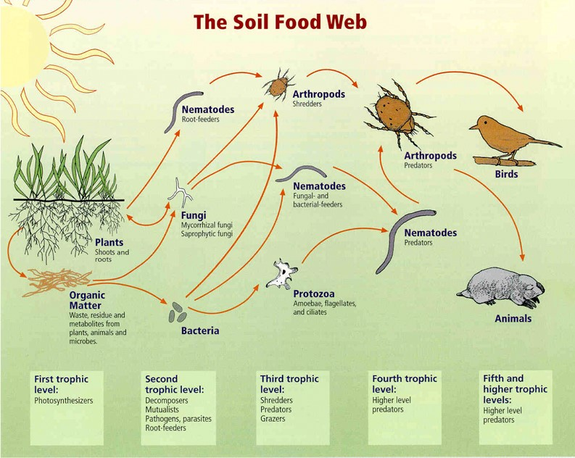

2. The Nutrient Cycle
- Photosynthesis: Plants use sunlight and Carbon Dioxide to make sugars. They send most of these sugars down to their roots and then send them out from the roots as exudates. These are exuded from the roots to the soil for aerobic bacteria and fungi to feed on. The purpose is to encourage them to amass around the roots and prosper to protect the plant, and to provide the plant the nutrients it needs.
- These ‘good guys’ have three important functions: a) they form a protective army to fight off the ‘bad guys’ (anaerobic micro-organisms responsible for disease); b) they contain the necessary enzymes and acids to break down and transform inorganic nutrients in soil particles and stones into organic nutrients suitable for plants; and c) they play a critical role in the formation of an aerated soil structure with passageways for Oxygen to pass through, which is necessary for water retention and for preventing the leaching of nutrients.

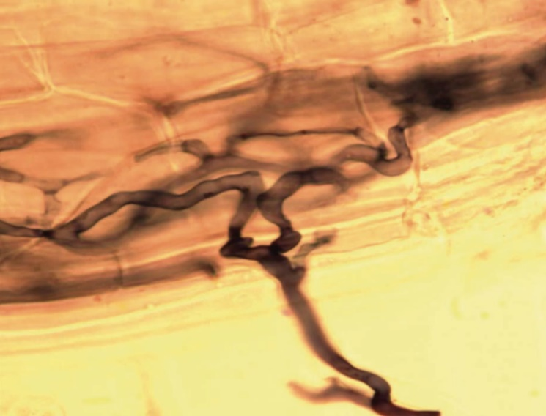
- The exudates feed the bacteria and fungi. The bacteria and fungi grow and produce enzymes to pull in nutrients. The fungi create networks of hyphae to obtain nutrients for the plant. The fungi produce organic acids to obtain nutrients from stones and pebbles. But at this stage, the nutrients that plants need are still locked up in the bacteria and fungi, and are only released when the latter die. To enable this to happen, there are predators in the soil to ensure constant nutrient recycling.
- In this case, the predators are protozoa, which eat bacteria; and nematodes and
micro-arthropods, which eat fungi. These predators then excrete the excess nutrients - now bio-available - into the surrounding
This shows a plant sending a liquid carbon exudate from a root to feed bacteria and fungi.

soil right by the roots where the bacteria and fungi are, thereby creating a constantly replenishing supply of food around the plant roots, where they are needed.
- When you cut a plant it sends out a huge amount of exudates through the root system. It sends out a massive amount of sugars, protein, and carbohydrates by means of these exudates. The bacteria and fungi respond by growing very rapidly. You then have more enzymes being produced to pull nutrients to the roots where they are stored in the bacterial and fungal biomass. However, they are not yet available to the plant until the protozoa, nematodes, and arthropods do their jobs. The bacterial-feeding protozoa and bacterial nematodes eat the bacteria. The fungal-feeding nematodes and fungal-feeding arthropods eat the fungi. Earthworms eat both. The 42 nutrients are then released in a high concentration right on the surface of the roots.

3. What Causes the Bacteria and Fungi to Grow in the Soil?
- You have to have organic matter. The plant produces and sends out exudates (the sugars produced by photosynthesis and which are pumped down to the roots and into the soil), which grow the bacteria and fungi. Plants will send an exudate to produce a bacteria or fungi to solubilize a nutrient it needs. The bacteria or fungi will then get the nutrient very quickly. Some exudates grow the fungi, which will produce the enzymes needed to obtain certain nutrients from the soil. A protozoa or nematode will then eat the bacteria or fungi so that the plant can get the nutrient it needs.
- As a result of sending out exudates all the time, the plant increases the biomass of fungi and bacteria on the roots, and thereby gets its nutrients so that it can grow more and more. The bacteria and fungi eat the exudates and grow, and create the soil structure, which enables the roots to penetrate deeper and obtain more nutrients, etc.

4. Where Does This Take Place in the Soil?
  - Right by the roots where the bacteria and fungi are. They eat the bacteria and fungi and release nutrients in a plant-available, chelated form. They release all 42 essential nutrients required by plants to be healthy in a plant-available form.
  - Chelated means “stuck to a protein or an amino acid”. Those proteins and amino acids are released when the bacteria and fungi are eaten. In a chelated form those nutrients can be taken easily into the roots.

5. What is the Effect of Chemical Agriculture on the Soil’s Biology?
- The biology in our soil is destroyed by tilling, by compacting the soil, and by the use of chemicals. As a result, the protozoa, nematodes, and arthropods are killed off, and when that happens, the Nutrient Cycle breaks down. Pests, disease, and weeds result.
- If the soil does not have enough of the 2nd Level protozoa, nematodes, and arthropods to obtain the nutrients (see diagram in part 1. above), then the plant will die.
- If the soil does not have enough of the 3rd Level protozoa, nematodes, and arthropods to eat the 2nd Level protozoa, nematodes, and arthropods in order to release the nutrients, which will diffuse into the roots and feed the plant, then the plant will die.
- If you have too many of the 3rd Level protozoa, nematodes, and arthropods eating the bacteria and fungi, then the plant will not get the nutrients it needs because either they will be stuck in the bacteria and fungi or there will be no bacteria and fungi around the roots, and the plant will die. So, you need the 4th Level nematodes and arthropods to eat the 3rd Level protozoa, nematodes, and arthropods to prevent the 3rd Level becoming scarce. Balance is essential.
- Humans are at the top of the 5th Level, but we are creating an imbalance in the soil through our ways of farming. Our job is to make sure that all those protozoa, nematodes, and arthropods are present. Then the soil biology will create fertile soil, and the plants will be healthy and free of disease. Bio-Plant and Pro-Plant will enable farmers to restore the balance in the soil biology.
- We need 75,000 species of bacteria per teaspoon for this Nutrient Cycle to work. Per acre we need about 1 million species of bacteria and about 750,000 species of fungi. In addition, we need several thousand species of protozoa, nematodes, and arthropods. However, we only know of about 5,000 different species of bacteria. So we cannot add all the species we need by ourselves. We do not even know how to grow each one. But if we make compost, the compost will create an environment where the bacteria and fungi species needed can grow.
- Bio-Plant enhances the compost-making process by providing a wide range of essential bacteria and fungi in a very high concentration of one billion cells per 1 cc, with each cell multiplying at the rate of one cell becoming one million in a day. The compost also provides a very rich environment for the protozoa, nematodes, and arthropods to multiply in. In this way, compost made with Bio-Plant can create the soil biology, which the plants need.

6. Compost is the Key to Sustaining Life.
- A farmer’s success is intimately bound up with the soil biology prevalent in the soil. The types, amounts, and ratios of bacteria, fungi and other microorganisms determine what crops will flourish, and indeed, whether they will flourish or not.
- It follows that what is growing is a good indicator of the soil biology; and it provides clues to where the imbalances might be in the soil, of what is preventing the farmer from growing the best crops he can. Again, the simple, quick, and easy way to fix problems in the soil biology is to inoculate the soil with compost.
- Compost is the nearest farming gets to a cure-all because it holds the key to sustaining life. It is cheap and easy, and as the soil becomes self-sustaining, the pest, disease, and weed problems go away and the crops are more productive. The crops become stronger, healthier and more nutritionally dense.
- Chemical fertilisers do not prove the 42 essential nutrients. 80% of the very few nutrients they do provide are washed out of the soil because chemical soil does not have the right soil biology or the organic matter and soil structure needed to hold the nutrients. Without the bacteria and fungi to bind soil particles together, the soil will not hold the nutrients, and they will leach.
- Chemical agriculture has a decimating effect on soil organisms because conventional, chemical farming involves tilling the soil, and using chemical fertilisers and pesticides, which kill the soil organisms. Compaction and erosion, which are common effects of chemical farming, also
ruin the soil biology.
7. Effect of Compost on the Soil Biology.
- Firstly, compost makes the soil an aerobic environment for soil bacteria and fungi to multiply in. The bacteria in the soil provide the glues, which hold the soil particles together. The glues are like the cement between the bricks of a house. They create passageways for Oxygen to aerate the soil and to make it aerobic.
- The fungi also help to build the structure of the soil by pulling together the bricks (soil particles) and by creating the holes in the soil through which the roots, air, and water can penetrate. These holes enable Oxygen to get into the soil, thereby enabling beneficial soil organisms to grow, while at the same time killing the pathogens and pests, which require reduced Oxygen conditions to grow in. As a result, creating the passageways is essential for plants to be healthy.
- By building the soil structure the bacteria and fungi help to increase the soil’s water-holding capacity. The organic matter holds 10x its weight in water, which means that the soil retains its moisture and has moisture in times of drought. Moreover, the nutrients are not lost through run-off or leaching, and they are available when the plants need them.
- To turn dirt, sand, or clay into soil you have to apply a lot of organic matter or compost so that the organisms can start to build soil structure, air passageways, etc. This will change the soil biology and create a healthy loam.
- The compost farmers make must be aerobic, so they must know how to make it and also cure it properly once it has been made. If it goes anaerobic (lacking Oxygen), then it will feed the disease-causing fungi, which we do not want to be dominant, and disease and pests will attack the plants. We will also lose the Nitrogen as ammonia, and the Phosphorus and Sulphur as gases. The pH may drop to as low as 2. Acidic soil makes the roots mushy, and the roots are unable to function properly. Also, we will be making alcohol, and alcohol kills plants. When the Oxygen level becomes low, the soil becomes anaerobic, and disease-causing fungi, protozoa, and nematodes will attack the roots. But, if the soil biology is good, the plants will even grow in drought and very low rainfall conditions.

8. A Balance of Bacteria and Fungi is Needed.
- Farmers need to know the ratio of bacteria to fungi for their particular crops. To grow vegetable crops with a high yield they will need a ratio of 1:1. To grow trees, there should be more fungi.
- Both fungi and bacteria are responsible for the decomposition of plant residues and for the release of plant nutrients. However, they have different roles in the recycling of nutrients due to their different choice of habitats within the soil and the different types of organic matter they consume. Therefore, the balance of fungi and bacteria in the soil is important for optimal soil biology. The more bacteria and fungi there are in the soil, the healthier the soil will become, weeds will not be a problem anymore, and there will be no disease.

Soil Biological Succession Causes Plant Succession
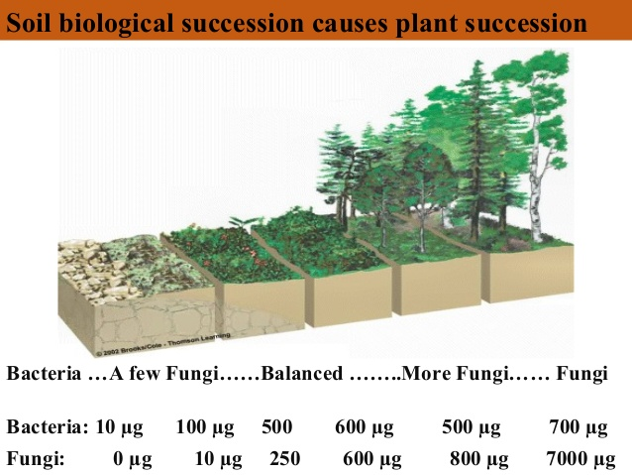

9. Why do We Want a Lot of Fungi?
- Beneficial fungi protect our plants from disease by:
- Out-competing disease organisms.
- Creating a healthy soil biology.
- Offering direct protection to our plants by producing anti-pathogens.
- Providing nutrients and water directly to the plants for better plant health.
- Mycorrizal fungi help plant roots absorb nutrients and fight off harmful, soil-dwelling predators. They physically attach themselves to the roots of plants and extend the ‘reach’ of the plant’s roots, mining for water and nutrients in the soil that plants have a hard time accessing with their own roots alone. String-like hyphae form interwoven string networks. These networks have a massive surface area and are very effective at extracting nutrients and water from the soil and mulch.
- Vegetable crops generally enjoy an evenly matched ratio of bacteria and fungi (though leaning a bit towards bacteria.) On the other hand, most perennials, shrubs, and trees like the soil to be full of fungi at ratios from 10:1 to 50:1. Fruit trees and cocoa trees need a lot of fungi. Mulch, cover crops, and compost increase the fungi in the soil.
- When making compost aim for a 30:1 Carbon to Nitrogen ratio because fungi like a lot of Carbon. Compost made with Bio-Plant will provide the fungi and the environment for them to grow in. Include in the compost plants with good cellulose content, such as rice, maize, and wheat stalks; straw; pruned branches; cocoa pods; etc. Fungi are the predominant cellulose decomposers. Cellulose has a high carbon content and a corresponding high C:N ratio, making it the ideal food source for fungi.
- In contrast, bacteria, which have a smaller C:N ratio than fungi, need food rich in Nitrogen (e.g. green manure, legume residues). A fertiliser rich in Nitrogen favours the bacterial community in a soil whereas a substrate with a relatively wide C:N ratio enables growth of the fungal population.
- Farmers will increase their crop yield by increasing the fungi content of their soil; reduce their weed problem; and increase the disease protection. Why? Because the soil biology will be improved more and more by doing this. As this happens, the nutrient cycling is improved more and more. The plants will get fed faster, and they will grow faster and become healthier. Compost made with Bio-Plant will add a lot of fungi (and bacteria) to the soil.
- The key for farmers is to restore the soil biology and to maintain it. They have to keep increasing the bacteria, fungi, protozoa, nematodes, and arthropods. So, including mulch and cover crops in the farming system is needed too.
- A balance of bacteria and fungi is needed for another reason. The glue, which the bacteria make, is alkaline. The pH in a bacterial-dominated soil is alkaline. Fungi produce organic acids. These organic acids will keep the pH between 5.5 and 7. So you want to have a lot of fungi in the compost and the soil.
- Planting chamomile, horkellia parryi, oreganum, chrysanthemum, thyme, Penstemon heterodoxus, and perennial herbs as an understory cover crop is beneficial for farmers because they create a balance of bacteria and fungi. Chamomile will increase the fungal biomass.
- Perennial plants will increase the length of the roots. Healthy root systems, allowed to grow over multiple seasons, are essential for fostering plant-protecting organisms in the soil.
- When you germinate a seed and plant it, if the low cover crop is already growing, the mycchorhizal fungi will extend to its roots and start to provide nutrients. The seed will then grow much more quickly.

10. Eradicating the Problem of Weeds.
- Weeds grow best in a soil, which lacks Oxygen; which has a poor structure; which is high in nitrates (caused by chemical fertilisers); which is compacted; or which is left bare.
- If the roots of plants cannot grow deep, the weeds will grow. However, when the soil is not compacted the roots can grow deep down into the soil, open the soil up and bring in Oxygen, which weeds do not like. Insects, such as earthworms, will go into those holes and build the soil structure further and increase the Oxygen supply in the soil.
- In addition, by growing cover crop plants with a large root system, such as ryegrass, the roots will build a large network of mycorrhorizal fungi, which will suck nutrients from the weeds and make them suffer in the soil.

11. Are the Roots of Vegetables Longer When There is Life in the Soil?
- Yes they are. In chemically maintained management systems, soil life is killed and then the soil compacts rapidly, as it rains or the soil is irrigated. Compaction forms at 2 to 4 to 6 inches typically, which encourages weeds to flourish. Tillage is then "required" to break up that compaction, except that tillage slices, dices, crushes, and destroys soil life, the very things that would build soil structure, if they were allowed to stay alive.
- The transition back to healthy soil requires time to return the beneficial organisms to the soil. Let them build micro-aggregates (bacteria using their glues), and macro-aggregates (fungi using the filaments they grow), to break up the compaction and thus allow roots to grow deeper into the soil.
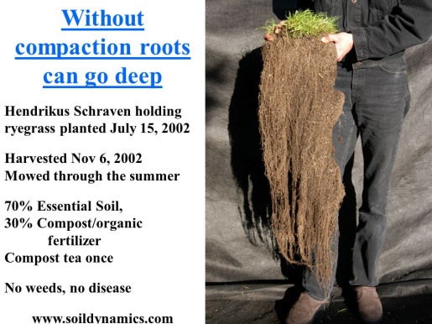
- At the end of the growing season, instead of leaving the soil bare, plant ryegrass because it will grow long roots, which will maintain the soil biology.

- As the compaction is broken up, the root system will increase, the soil will become aerobic, the bacteria and fungi will multiply, provide more nutrients and water to the roots, and in return the plant will provide more exudates through the roots for the bacteria and fungi to multiply in more.
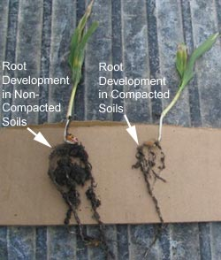

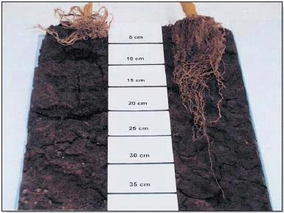
Maize plant roots in compacted (left) and non-compacted soils (right).

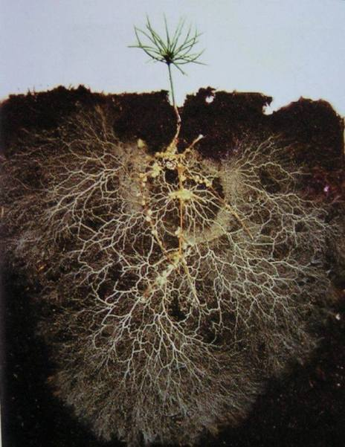
Plant roots and the network of fungi
in fertile and uncompacted soil.

