The Nature and Benefits of Bio-Plant, Liquid, 100% Organic, Microbial
Bio-fertilizer, and of Compost Made With It

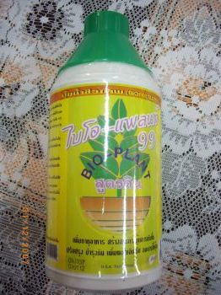

1. Introduction

- Bio-Plant is a liquid, 100% organic, toxin-free, and chemical-free, microbial bio-fertilizer made using sugarcane molasses with advanced bio-technology. It is very rich in micro-organisms.
- The micro-organisms in Bio-Plant are especially useful in improving the physiology and biology of the soil, and in restoring it to fertility even when the soil has been weakened by many years of chemical agriculture.
- There are many kinds of micro-organisms naturally present in Bio-Plant, but we add cultures that serve specific purposes in strengthening the health and immunity system of the plants, in transforming the fertility of the soil, in increasing the amount of major and minor minerals for the plants, and in increasing the growth of the plants. The ability of the micro-organisms in Bio-Plant to carry out their normal functions is increased through bio-technology processes, which the company founder has created.
- Certain micro-organisms fix Nitrogen from the air. When you apply Bio-Plant to the soil, the micro-organisms colonize crop roots and start to multiply. They bind with the root hairs and cause root cells to swell, forming nodules. Within these nodules, the bacteria work as miniature “Nitrogen factories,” pulling Nitrogen from the air and converting it into a form the plant can use. Certain other micro-organisms produce additional Nitrogen in different ways.
- The micro-organisms accelerate growth, immunize against pathogens, decompose organic matter, extract nutrients for the plants, and turn the huge amount of NPK that chemical fertilizers leave unused in the soil into a form that the roots can absorb. They thereby act like a broom and sweep up the chemical deposits. As a result, they provide the plants with a large amount of Nitrogen, Phosphorus, and Potassium. The soil becomes aerated, loosened, crumbly, and fertilized so that the plants can absorb nutrients consistently.

2. Microbial Activity in Liquid Fertilizer

2.1 Bio-Plant: 1 cc of the microbial liquid fertilizer is composed of 10⁹ microorganisms, with each cell multiplying into a million cells in the soil within one day. When the micro-organisms have organic matter or the chemical NPK soil deposits to feed on, and multiply at this rate, the microbial life of the soil can be restored quickly. If the guidelines are followed, hard, weak, chemical soil that has been weakened by 20 years of chemical agriculture can be restored to fertility in 2-3 years.
2.2 The 4 Groups of Micro-organisms
- Bio-Plant contains 4 main groups of micro-organisms:
- Group 1: Micro-organisms Which Produce Nitrogen
- Group 2: Micro-organisms Which Produce Phosphorus
- Group 3: Micro-organisms Which Produce Potassium
- Group 4: Micro-organisms Which Produce Other Minerals

- Each kind of plant needs different minor elements. These elements exist naturally, but in an unusable form. They need some micro-organisms to transform them into a usable form. This is what Bio-Plant does. In addition, Bio-Plant and Pro-Plant increase the amount of roots for the extra volume of minerals to be absorbed through, and generally, an extra 20% of roots can be observed. This helps to increase the growth rate and the crop yield.

Group 1: Micro-organisms Producing Nitrogen
- Nitrogen is a major nutrient for a plant. When plants are Nitrogen deficient, they are marked by reduced growth and yellowing of leaves. Soil that is consistently cultivated always lacks Nitrogen since it easily decomposes in the form provided by chemical fertilizer. Bio-Plant not only makes soil-based Nitrogen available, but also fixes Nitrogen from the air, thereby providing an abundance of Nitrogen. These micro-organisms use an enzyme to transform Nitrogen gas into amino acids and other forms of Nitrogen that are useful for a plant. Plants not only obtain more Nitrogen from the soil as a result of the micro-organisms, but they also obtain extra Nitrogen by Nitrogen fixation from the air. This increases the growth in a positive and environmentally safe and effective way.

The Nitrogen Cycle
- The Nitrogen Cycle is the continuous flow of Nitrogen through the biosphere by the processes of Nitrogen fixation, ammonification (decay), nitrification, and denitrification. Bio-Plant has a positive effect on the Nitrogen Cycle in crops and enables plants to obtain a larger amount of Nitrogen in a more efficient way than by piling on extra bags of NPK or Urea. Nitrogen is vital to all living matter, both plants and animal; and is an essential constituent of amino acids, which form proteins of nucleic acids, and of many other organic materials.

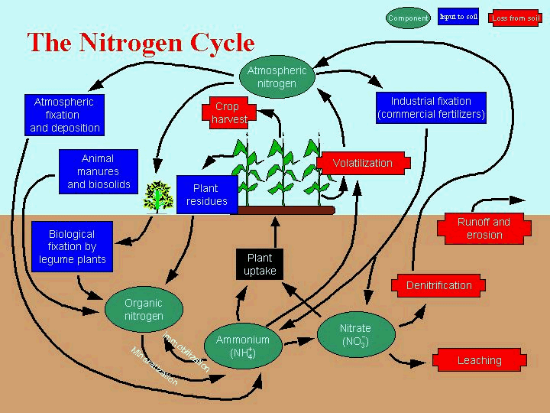
Nitrogen Fixation
- Although the earth's atmosphere is made up of 78% Nitrogen, free gaseous Nitrogen cannot be utilized by animals or by higher plants. They depend instead on Nitrogen that is present in the soil. Bio-Plant changes this by enabling Nitrogen fixation from the air to taken place.
- To enter living systems, Nitrogen must be “fixed” (combined with oxygen or hydrogen) into compounds that plants can utilize, such as nitrates or ammonia. A certain amount of atmospheric Nitrogen is fixed by lightning and by some cyanobacteria (blue-green algae). But the great bulk of Nitrogen fixation is performed by soil bacteria of two kinds: those that live free in the soil and those that live enclosed in nodules in the roots of certain leguminous plants (e.g., alfalfa, peas, beans, clover, soybeans, and peanuts). They use the energy from decaying organic matter in the soil to fuel soil processes, including Nitrogen fixation. Both kinds are present in Bio-Plant.
- Bacteria that live in the roots of legumes are found in Bio-Plant. They enter the roots chiefly through the root hairs and then work their way to the inner root tissues. There they stimulate the growth of tumor-like nodules. Within the nodules the bacteria develop into forms called bacteroids, which live in a symbiotic (mutually beneficial) relationship with the green plant. The bacteroids take carbohydrates from the plant for energy to fix Nitrogen and synthesize amino acids; the plants take the amino acids elaborated in the nodule to build plant tissue.
- It is estimated that more than 300 lbs of Nitrogen per acre (340 kg per hectare) can be fixed by means of Nitrogen-fixing micro-organisms. After a harvest, legume roots left in the soil decay, returning organic Nitrogen compounds to the soil for uptake by the next generation of plants. This is one reason why Bio-Plant is so beneficial to plant growth.

Other Aspects of the Nitrogen Cycle
- Decomposing animal remains and animal wastes also return organic Nitrogen to the soil as ammonia. Many different kinds of micro-organisms participate in ammonification. Bio-Plant has nitrifying bacteria that oxidize the ammonia to nitrites, and other bacteria that oxidize the nitrites to nitrates. The nitrates can then be taken up again by the plant. The cycle of fixation-decay-nitrification-fixation can proceed indefinitely without any Nitrogen being returned to a gaseous state.

Group 2: Bio-Plant Contains Micro-organisms Which Produce Phosphorus
- Phosphorus is a nutrient that is as important as Nitrogen for a plant. There is, of course, Phosphorus within the soil, but it is not usable in soil with a pH that is too high or too low. Bio-Plant not only produces extra Phosphorus for plants, but it also restores the natural balance to soil so that the pH moves up or down to about 7.
- Microbial fertilizer, Bio–Plant, consists of some kinds of micro-organisms that can absorb Phosphorus easily and can dissolve chemical fertilizer.

Phosphorus and the Phosphorus Cycle
Phosphates
- In the early 1800s, chemists recognized that the critical component in bones was Phosphorus, which plants use in photosynthesis—the biological conversion of energy from the Sun into chemical energy. With this discovery came the realization that Phosphorus would make an even more effective fertilizer when treated with Sulphuric acid, which makes it soluble, or capable of being dissolved, in water. This compound, known as superphosphate, can be produced from phosphates, a type of mineral. Bio-Plant replaces the need for this acid to be added to soil by dissolving Phosphorus left unabsorbable in the soil by chemical fertilizer.

The Phosphorus Cycle
- Phosphates represent one of the eight major classes of mineral. All phosphates contain a characteristic formation, PO₄, which is bonded to other elements or compounds—for example, with aluminum in aluminum phosphate, or AlPO₄. Phosphorus fertilizer is typically Calcium phosphate, known as bone ash, the most important industrial mineral produced from Phosphorus.
- The majority of Phosphorus in the earth system is located in rocks and deposits of sediment, from which it can be removed by one of three processes: weathering, the breakdown of rocks and minerals at or near the surface of Earth as the result of physical, chemical, or biological processes; leaching, the removal of soil materials that are in solution, or dissolved in water; and mining.
- Phosphorus is highly reactive, meaning that it is likely to bond with other elements, and for this reason it often is found in compounds. Micro-organisms in Bio-Plant absorb insoluble Phosphorus compounds (ones that are incapable of being dissolved) and, through the action of acids within the micro-organisms, turn them into soluble phosphates. This is one way in which Bio-Plant helps the soil. Algae and other green plants absorb these phosphates and, in turn, are eaten by animals. When they die, the animals release the phosphates back into the soil.
- A shortage of Phosphorus in the soil would make it especially difficult for a plant to manufacture flowers from which fruit appears. Inorganic Phosphorus in the form of the phosphate PO₄³⁻ plays a major role in biological molecules, Plants need phosphate from the soil to make their DNA.
- Phosphate-solubilizing micro-organisms in Bio-Plant, convert non-available inorganic Phosphorus present in soil into an available form utilizable by crop plants. These bacteria also produce iron chelating substances, called siderophores, which chelate the iron present in the root zone. As a result, this iron becomes non-available to harmful micro-organisms and, in this manner, crop plants are protected from them. In addition, certain fungi, e.g., Glomus, etc., form associations with plants roots. These are called mycorrhiza.
- By enabling plants to absorb the residues of Phosphorus, it minimizes the impact of the residues on surface water quality.

Group 3: Micro-organisms Which Produce Potassium
- Potassium is another major substance that plants get from the soil. It is used in protein synthesis and other key plant processes. Yellowing, spots of dead tissue, and weak stems and roots are all indicative of plants that lack enough Potassium.
- Plants need Phosphorus, a component of nucleic acids, phospholipids, and several proteins. It is also necessary to provide the energy to drive metabolic chemical reactions. Without enough Phosphorus, plant growth is reduced. Since Potassium has a major role in protein, carbohydrate and fat synthesis, the quality and quantity of crop yield depend on Potassium. Potassium in the soil is fixed, dissolvable, and exchangeable. The most rapid and appropriate way to use Potassium is by bio- and organic weathering by Bacillus organisms which tolerate the soil’s pH. Bio-Plant contains these organisms and by making more Potassium available to the plants by dissolving it, it improves the quality of fruit in terms of texture and taste.

Group 4: Microorganisms Which Produce Other Minerals
- Each kind of plant needs different minor elements. Naturally, these elements exist, but in an unusable form. They need some microorganisms to transform them into a usable form. Bio-Plant contains micro-organisms that make these minor elements available to the plants.

Bio-Plant and Compost Made with Bio-Plant Make Available to the Roots the 80% of Chemical Fertiliser NPK, which is Lost Unabsorbed in the Soil

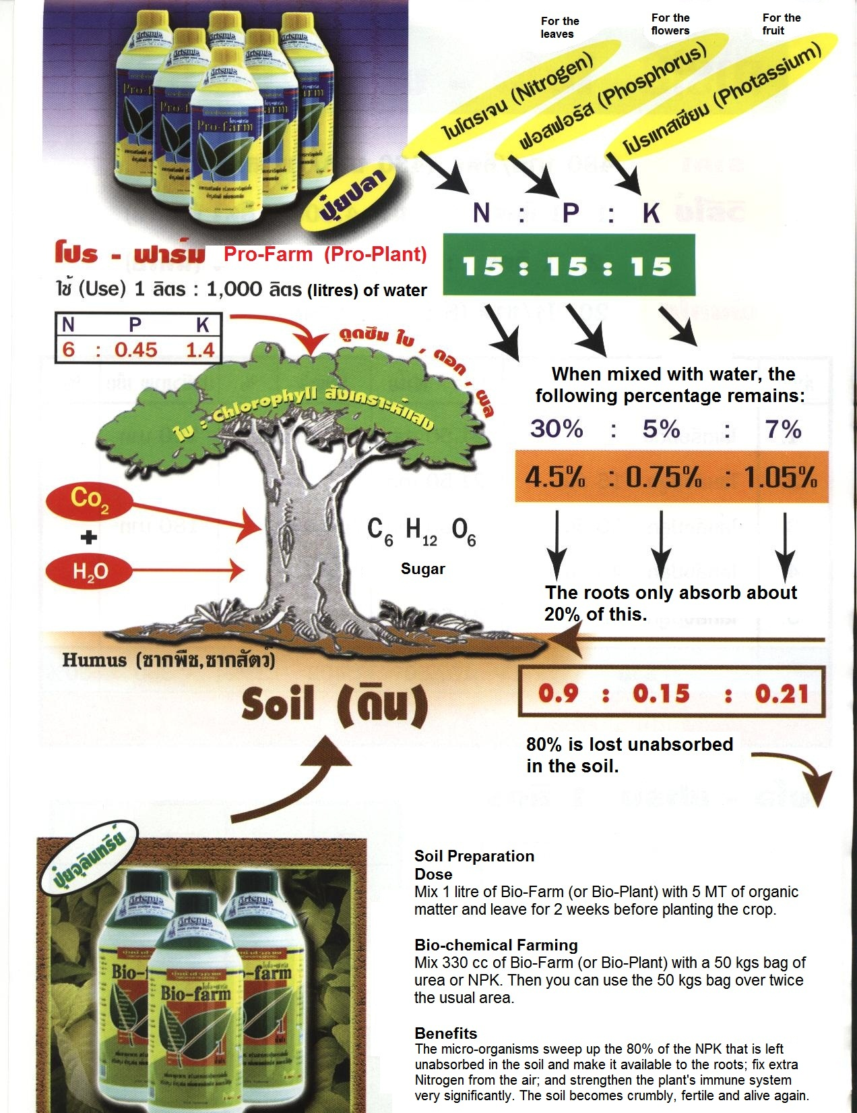
3. Additional Benefits of Bio-Plant

3.1 Decomposers and Detritivores
- Most biogeochemical cycles involve a special type of chemical reaction known as decomposition, and for this to take place, agents of decomposition—known as decomposers and detritivores—are essential. The micro-organisms of Bio-Plant act as decomposers and this is one way that they make more nutrients available to the plants than chemical fertilizers do.
- Decomposition occurs when a compound is broken down into simpler compounds or into its constituent elements. This is achieved primarily by decomposers, organisms that obtain their energy from the chemical breakdown of dead organisms as well as from animal and plant waste products.
- The principal forms of decomposer are micro-organisms and fungi. These creatures carry enzymes, which they secrete into the materials they consume, breaking them down chemically before taking in the products of this chemical breakdown. They thus take organic matter and render it in inorganic form, such that later it can be taken in again by plants and returned to the biosphere.
- Detritivores are much more complex organisms, but their role is similar to that of decomposers. They, too, feed on waste matter, breaking this organic material down into inorganic substances that then can become available to the biosphere in the form of nutrients for plants. Examples of detritivores are earthworms and maggots. Detritivores are key players in the food web, the set of nutritional interactions—sometimes called a food chain—between living organisms. The activity of the micro-organisms in Bio-Plant breaks up the soil, making it crumbly and fertile, and this attracts back the detritivores that are no longer found in soil where chemical fertilizer has been over-used.

4. Fungicide and Herbicide

- While emphasizing that Bio-Plant is a bio-fertilizer and not a replacement for insecticides, pesticides, fungicides, and herbicides, it can be used for additional purposes when applied in higher doses. For example, some farmers use Bio-Plant as an organic herbicide to kill weeds by providing a stronger than normal dose. Others also use Bio-Plant as an effective, natural fungicide, such as on the tapped area of rubber trees, thereby increasing the flow of the latex. Bio-Plant also interrupts the life cycle of soil-borne insects and reduces them at the rate of about 20% per year.
- The micro-organisms also protect the roots and the plants from fungus.
- In cases where the farmers have crop diseases we would ask them to mix Bio-Plant with the Pro-Plant in water (at the ratio of 5 cc Bio-Plant + 20 cc Pro-Plant in 20 litres of water) as the extra input of micro-organisms will protect the plants from infecting fungi and bacteria and also improve their immune system. Bio-Plant can also be used to get rid of viruses on trees, again, when used in a high dose. Viruses, such as this one on mango trees in the Philippines:

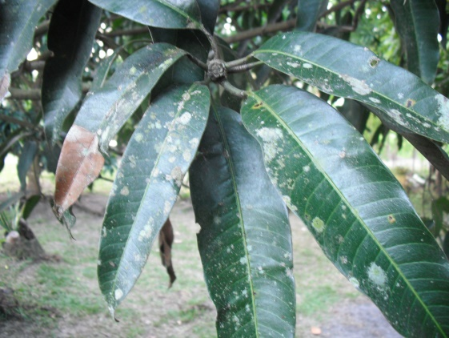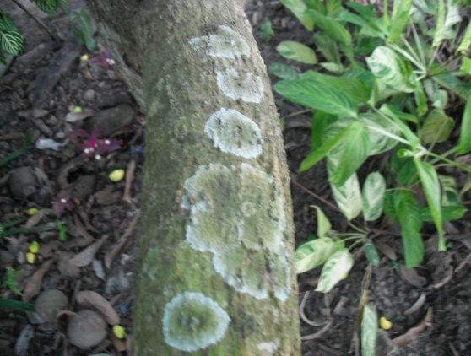

5. Summary of the Main Advantages of Bio-Plant

1. Bio-Plant increases both major and minor nutrients in the soil.
2. Bio-Plant activates growth.
3. Bio-Plant formulates growth stimulants.
4. Bio-Plant makes the plants resistant to plant pests.
5. Bio-Plant improves the soil quality, and soil made hard by chemical fertilizer becomes soft.
6. Bio-Plant removes chemicals in the soil left by chemical fertilizer.
7. Bio-Plant reduces chemical fertilizer by half when Bio-Plant is used with chemical fertilizer.
8. Bio-Plant reduces fertilizer costs significantly in 100% organic farming.
9. Bio-Plant increases crop productivity significantly compared to chemical fertilizer.

6. General Benefits of Compost Made with Bio-Plant

6.1 Lower Soil Fertility Costs
- Optimizes soil fertility, increases crop yields, and lowers fertilizer and water inputs.

6.2 Increases Soil Organic Matter
- This extra organic matter improves and maintains soil quality.
- The Ohio State University Extension estimates that every 1% additional amount of soil organic matter contains over $650/acre worth of nutrients (N, P, K, S) available for crop production.
- Compost made with Bio-Plant contains soil organic matter, nutrients, humic acids, amino acids, plant growth hormones, and a wide range of beneficial microorganisms.
- Field studies have established that incorporating compost over a 2-year period positively affects the structure, porosity, water holding capacity, compression strength, nutrient content, pH, and organic matter content of the soil, which results in improved plant growth, crop yield and quality.

6.3 Increases Water Holding Capacity and Infiltration Rates
- For each 1% of soil organic matter that the compost adds, the soil water storage capacity will increase by up to 75,000 litres per acre per rain event (equivalent to 1" of rainfall).
- Increasing water holding capacity and soil aggregates will help to retain nutrients while reducing erosion and sedimentation losses, thus protecting the watershed.
- The compost contains billions of microorganisms, which accelerate the conversion of crop residues into plant-available forms of Nitrogen (N), Phosphorous (P) and other key nutrients.
- The compost increases the production of plant and microscopic biomass, which lock up nutrients that might otherwise leach into the water table. These aggregated nutrients become the following year’s reservoir of aggregates and soil organic matter.
- Field studies have determined that compost-amended soils exhibit higher potential denitrification rates, greater denitrification efficiency, higher organic matter, and greater microbial activity while reducing harmful nitrate leaching by 5 times compared to conventionally farmed soils.

6.4 Increases Soil Disease Suppression
- The beneficial microorganisms minimize, prevent, and suppress root and foliar diseases caused by soil-borne pathogens, such as Fusarium, Phytophtora, Pythium, and Rhizoctonia. Unlike chemical fungicides, the compost provides naturally occurring plant growth hormones, humic acids, organic matter, and nutrients that are essential for combating diseases while building healthy soil and healthy plants.
- The compost directly affects disease-causing organisms by stimulating Systemic Acquired Resistance and Induced Systemic Resistance to pathogens in soil.
- The protective microorganisms rapidly colonize the soil and then uses multiple modes of action to combat plant pathogens, minimize the effects of soil diseases and reduce the likelihood of developing disease resistant strains of soil pathogens.
6.5 The Compost Produces Antibiotics That Kill Pathogenic Microorganisms.
- The compost activates systemic acquired resistance and induced systemic resistance defense mechanisms in the soil. Both confer long-lasting protection against a broad spectrum of pathogenic microorganisms.

6.6 Mycorrhizal Fungi
- The compost contains multiple strains of mycorrhizal fungi known to form beneficial relationships with crops. Mycorrhizal fungi (MF) are naturally occurring symbiotic fungi that colonize the roots of plants and exchange nutrients for sugars from the plant's roots. Unfortunately, agricultural practices such as chemical fertilizer applications, crop rotation, tillage and liming can damage and ultimately destroy MF root colonization levels, leaving crops vulnerable to drought, disease and nutrient deficiency.
- MF colonization increases root, stem and leaf weights, leaf area, and root length by as much as 100%.
- MF increase mobilization and transfer of nutrients (P, N, S, micronutrients Cu, Zn) from the soil to the plant.
- MF increase root absorption capacity for nutrients and water, which promote better adaptation to drought.
- MF reduce the susceptibility of roots to soil-borne pathogens such as nematodes or Phyto-pathogenic fungi, such as Fusarium Oxysporum, Fusarium Solani, Rhizoctonia Solani and
Macrophomina phaseolina.
- MF secrete Glomalin into the soil, which stabilizes soil aggregates and sequesters carbon dioxide.

6.7 Increases Crop Yields
- Field Studies consistently demonstrate how multiple compost applications increase soil organic matter, soil water holding capacity, microbial activity, nutrient cycling, and plant growth. As soil conditions improve, soil disease pressure lessens, crop yields increase by varying amounts. Simply put, soils high in organic matter outperform soils with low organic matter.

6.8 Cation Exchange Capacity
- Studies show that adding compost to soil can increase cation exchange capacity by 300% or more. The availability of micronutrients to growing plants depends upon soil pH levels and organic matter content. In general, if the soil pH decreases, the availability of most micronutrients increases (more acidic); If the soil pH increases (more alkaline) the availability of micronutrients decreases. The humic substances in compost made with Bio-Plant chelate, or form complexes with micronutrients. Chelated micronutrients are more available to plants, even at higher pH levels.

6.9 Humic Acid, Fulvic Acid and Humates
- Humic subtances (humic acids, fulvic acids and humates) have been studied extensively and proven to enhance plant growth and increase crop yields. Humic substances are one of most active and important soil organic matter fractions because they bond with silt, clay, carbohydrates and nutrients to form soil aggregates. Aggregates form the crumbly soil structure responsible for tilth, water holding capacity, water infiltration, cation and oxygen exchange and serve as the major reservoir of plant nutrients. Humic substances also buffer the soil pH and mineralize Nitrogen (N) and phosphorous (P) nutrients and trace elements into plant absorbable forms.
- During the composting process, humic subtances are naturally formed from the decomposition of organic matter by bacteria and fungi. The compost encourages diverse groups of microbes to thrive, multiply and build-up high concentrations of stable humic substances in our high-quality humus compost.

6.10 Guaranteed Quality
- Bio-Plant has been independently tested many times and analyzed for biological, chemical, and physical factors, such as pathogens, heavy metals, pesticides, inerts, nutrients, pH, salts, moisture, organic matter, and stability to assure crop safety, public safety and environmental protection.
- Compost made with Bio-Plant optimizes crop yields by producing healthier soils, vigorous root and shoot systems and stronger, healthier plants.

